***Frontend Development with React.js***

***Project Documentation for FitFlex***

**1. Introduction**

* **Project Title: FITFLIX**
  1. ***Team Members***:
  2. **FAMITHA SB** (**Team Leader**) **[**Email Id: [sheikbuhhh@gmail.com](mailto:sheikbuhhh@gmail.com)**]**
  3. **[**Ensuring the project output and collaborating with other team members. Troubleshooting technical issues**]**
  4. **VARSHINI VR [**Email Id: [rathik132@gmail.com](mailto:rathik132@gmail.com)**]**
  5. **[**Planning, Organizing and executing the project. Troubleshooting technical issues and offering solution for that**.]**
  6. **SATHVIKA E [**Email Id: [sathvikavimala0@gmail.com](mailto:sathvikavimala0@gmail.com)**]**
  7. **[**Test the product for bugs, report defects, and ensure quality control and also created the demo video for this project**.]**
  8. **JANANI MS [**Email Id: [jananims0204@gmail.com](mailto:jananims0204@gmail.com)**]**
  9. **[**Managed the documentation for this project. Keeps the design consistent with the project’s brand identity and goals**.]**
  10. **HARINI M [**Email Id: [harinim021@gmail.com](mailto:harinim021@gmail.com)**]**
  11. **[**Keeps the design consistent with the project’s brand identity and goals**.]**

**2. Project Overview**

* ***Purpose***: To provide an easy to use platform that helps users stay fit and motivated. To integrate fitness, nutrition and mental well-being in a single app.
* ***Goals***: Promotes Healthy Lifestyles Personalized workout plans Suggests Equipment’s to the exercise.

**3. Architecture**

* ***Component Structure***:
  + The **Footer.jsx** component could display legal information, links to social media, or any other bottom content.
  + The **About.jsx** component is typically used to provide some information about the application, such as what it does, how it works, or who created it.
  + A **Homesearch.jsx** component could be a feature that allows users to search for exercises, workouts, or fitness resources directly from the home page.
* **Hero.jsx** component is typically the first prominent section of the user interface that appears when someone lands on the homepage or the app's main screen.
* ***State Management*:**
* It is used to perform interactivity, consistency and communication.[Eg:context API]
* ***Routing:***
* Routing refers to the process of determining which component should be displayed based on the URL.

**4. Setup Instructions:**

* ***Prerequisites:***
  + This project requires Node.js to run. It also comes with npm, which is used to install the dependencies.
  + Need a code editor to work on the project. By using Visual Studio Code as used for this project.
* ***Installation:***
* Install Node.js & npm
* Install the dependencies by running this command: npm install
* This command reads the package.json file in your project and installs all the libraries listed there (like React, React Router, etc.)

**5.Folder Structure:**

* ***Client***: The client folder is where all the React-related files live, including components, pages, styles, and static assets. It follows a common structure that makes it easy to maintain and scale the app. Key components are organized into separate folders for better readability and reusability.
* ***Utilities:*** The utilities folder is essential for making your React application modular, clean, and easier to maintain. It centralizes reusable logic that can be accessed throughout the app, such as API calls, date formatting, validation, and other helper functions.

**6. Running the Application:**

* ***Frontend:*** The frontend of your fitness website is built using React.js, which is a popular JavaScript library for building user interfaces. The frontend is responsible for everything the user interacts with: the visual elements, the navigation, and the user experience.
* The frontend of your fitness website is built with React.js and follows a component-based **architecture**, where each part of the UI is split into reusable components. React Router is used for navigation, while CSS (or SCSS) provides the styling.

**7. Component Documentation:**

* ***Key Components:***
* ***Navbar*:** Main navigation links to sections (Home, Workouts, Profile, Login).
* ***Home Page*:** Introduction to the website and featured workouts.
* ***Login/Signup Page*:** Authentication for users to create or access their accounts.
* **Work out Catalog:** A list or catalog of available workouts for users to browse.
* ***Work out Details Page*:** Detailed information for each specific workout.
* ***Profile Page*:** User's personal profile and workout progress.
* ***Workout Tracker*:** A tool to track completed workouts and progress.
* ***API Integration*:** Backend API to fetch and submit data (workouts, user data, etc.).
* ***Footer*:** Contains additional links and information for the website.
* ***Reusable Components***:
* Reusable components are essential for maintaining a clean, efficient, and scalable codebase. These components are designed to be used in multiple parts of the application, allowing for a consistent user interface and simplifying code maintenance. By breaking down the
* UI into smaller, modular components, we avoid repetition and make the code easier to manage the Button component is a reusable UI element that can be used throughout the site wherever a button is needed, such as in forms, workout cards, or navigation. It accepts props like text, on Click, and style, which allow it to be customized based on its context. For instance, it can be used in the Homepage to start a workout session or in the Login Page to submit user credentials.

**8. State Management:**

* ***Global State:*** Global state plays a crucial role in managing shared data across various components. Instead of passing data manually through props from parent to child components (which can become tedious and inefficient as the project grows), global state allows for centralized data management that can be accessed from any part of the application. This ensures that critical data, such as user authentication status, workout progress, and user preferences, is consistently available across the entire application without unnecessary duplication
* ***Local State:*** Local state refers to data that is specific to a particular component in a React application and is typically managed using React’s built-in useState hook. Unlike global state, which is shared across multiple components, local state is confined to a single component and is used for managing data that doesn’t need to be shared across the entire app. This helps to keep the component self-contained and avoids unnecessary complexity.
* ***CSS Framework/Libraries***: CSS frameworks and libraries help speed up development by providing pre-built styles, components, and utilities.
* **Bootstrap:** Is one of the most popular CSS frameworks. It comes with pre-built responsive grid systems, buttons, forms, navigation bars, and other components, making it a great starting point for quickly building out your layout and design.
* **Tailwind:** Is a utility-first CSS framework, allowing you to style elements by adding classes directly in your HTML. It offers a great level of control and customization, letting you creates unique designs without writing custom CSS.
* ***Theming:***
* **Color scheme**: For this project we want to use dark and intense color for the background is used to evoke strength and determination.
* **Bold and strong fonts:** Is used to emphasizing strength and confidence.
* **UI/UX elements:** Minimalist Navigation like Home, About, Search; Call-to-action button is used to “view more”.

**9.Testing Strategy:**

* It is to ensure that all functionality works as intended, the website provides an optimal user experience, and it is robust across various devices and browsers. This strategy will include different types of testing to cover all aspects of the website, from UI/UX to performance and security**.**

**10. Unit Testing:**

* Test individual functions and methods in the codebase to ensure they perform their intended actions.

**11. Integration Testing:**

* Test how different components or systems (e.g., frontend and backend) work together.

**12.End-to-End Testing (E2E):**

* Test complete user journeys from landing on the site to completing an action, such as signing up, booking a session, or making a purchase.

**13.User Interface (UI) Test:**

Ensure that all visual elements, such as buttons, forms, and images, appear correctly and are responsive.

* **Code Coverage:** It refers to a metric used to determine the percentage of your codebase that is tested by your automated tests. It helps ensure that your tests are covering all relevant parts of the code, which increases the reliability and stability of your application. A high level of code coverage means that you are testing most (if not all) of your application's functionality, which helps catch potential issues before they make it to production.
* In a fitflex website project, achieving good code coverage can help ensure that all features—such as registration, workout plans, progress tracking, payment systems and user authentication—are working as expected and that no unintended side effects occur when changes are made.

**Screenshots or Demo:**

**Demo link:** <https://drive.google.com/file/d/1QVMDh8fnpqhugez4apLUV3LbtywyGFJr/view?usp=sharing>

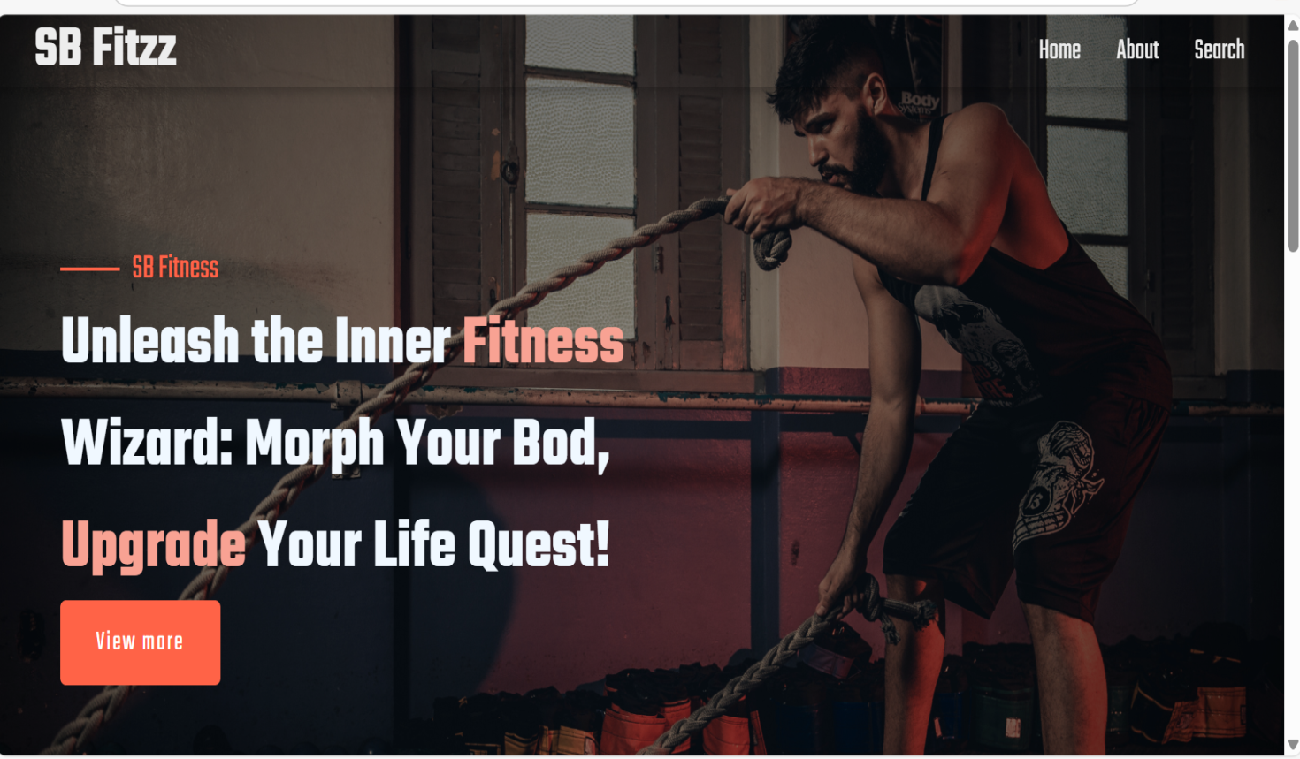

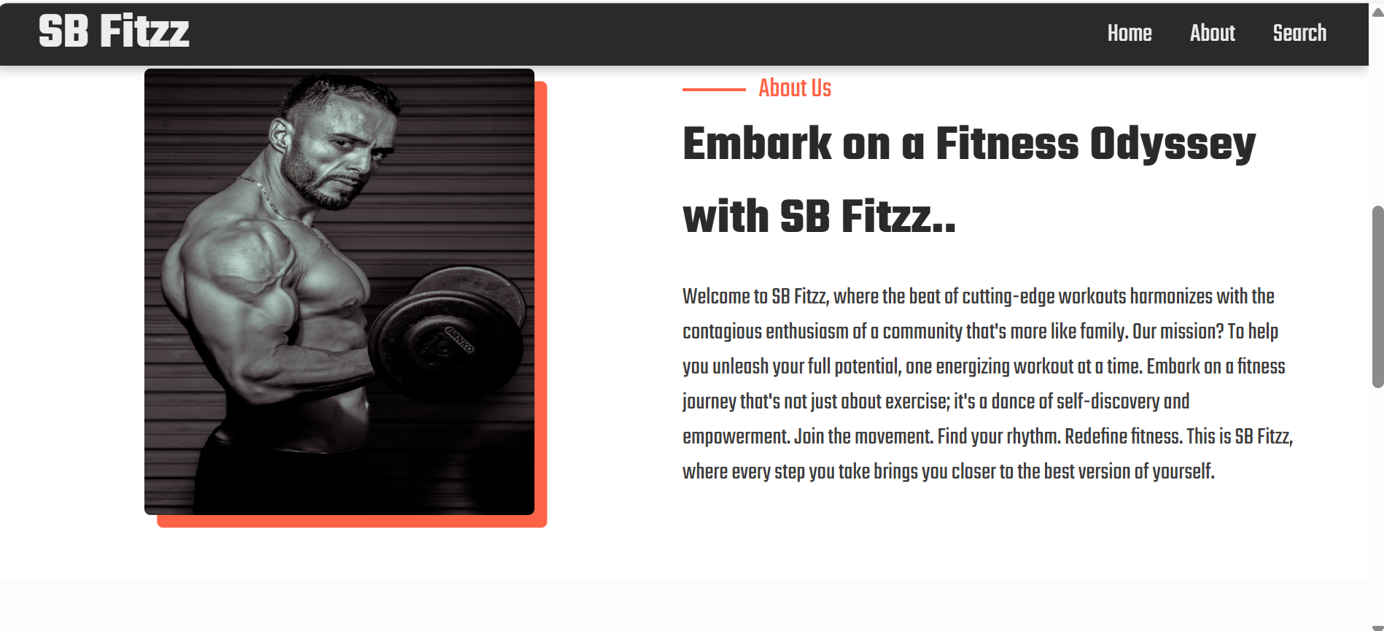

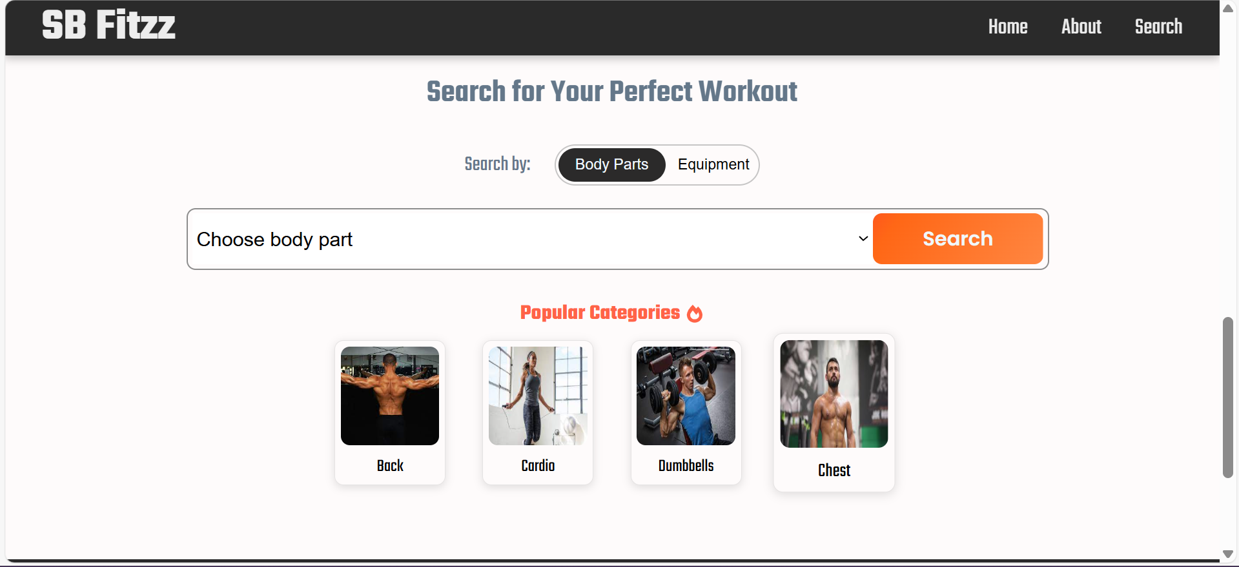

**14.Known Issues:**

* Slow Loading Times: Fitness websites, especially those with images, videos, workout tracking, and community features, can become resource-heavy. Slow loading can frustrate users and negatively impact retention rates.
* Addressing these known issues early in the development and testing phases will help ensure a smooth user experience, high user satisfaction, and long-term success for the FitFlex website. Regular updates, maintenance, and user feedback integration are key to avoiding or resolving these problems over time.

**15. Future Enhancement:**

* These future enhancements aim to make the FitFlex fitness website a more comprehensive, personalized, and engaging platform that combines technology, wellness, and community. Whether through AI-driven customization, social features, or integrations with wearable devices, these updates can improve the overall user experience and keep the platform competitive and relevant in a growing market.
* Description: Introduce features focused on mental wellness, such as meditation, mindfulness, and stress-reducing activities.
* Future Enhancement: Integrate with apps like Headspace or Calm for guided meditation sessions or relaxation exercises that complement physical fitness routines.
* Benefits: Fosters a holistic approach to fitness by addressing mental well-being along with physical health.